Final Project Report: BeePlan
1. Project Information & Repository Access ²
- Project Name: BeePlan ³
- Developer: Hasabu Can Eltayeb - Role: Student A ⁴
- GitHub Repository Link: https://github.com/cozalss/SENG383-project/tree/main ⁵
- Repository Content Check: Clicking the link reveals the following folders: ⁶
  - /src: Source Codes (Clean Code & Error Handling) ⁷
  - /docs: Diagrams and Reports ⁸
  - /video: Final Presentation Video ⁹
  - README.md: Installation and Running Instructions ¹⁰

2. Final Design Artifacts ¹¹
2.1.
Class Diagram ¹²
The final version of the project follows an MVC (Model-View-Controller) structure. The SchedulerAlgorithm class manages the backtracking logic, while ScheduleModel stores Course and Room data.
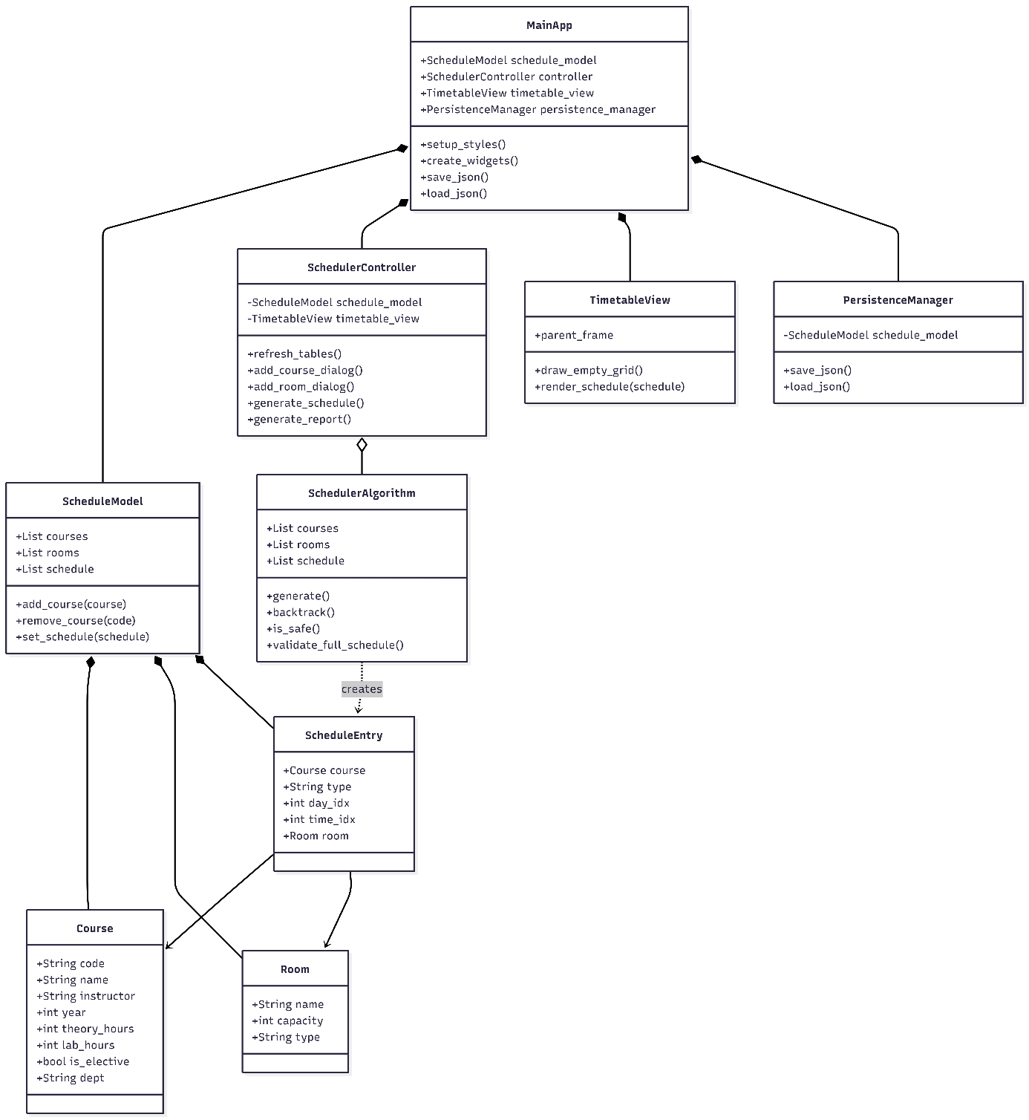

2.2.
Activity Diagram ¹³
The system begins by breaking courses into hour blocks (PrepareTasks) and sorting them by year/type. The main loop uses a backtracking algorithm to check for conflicts and assign entries to valid slots.

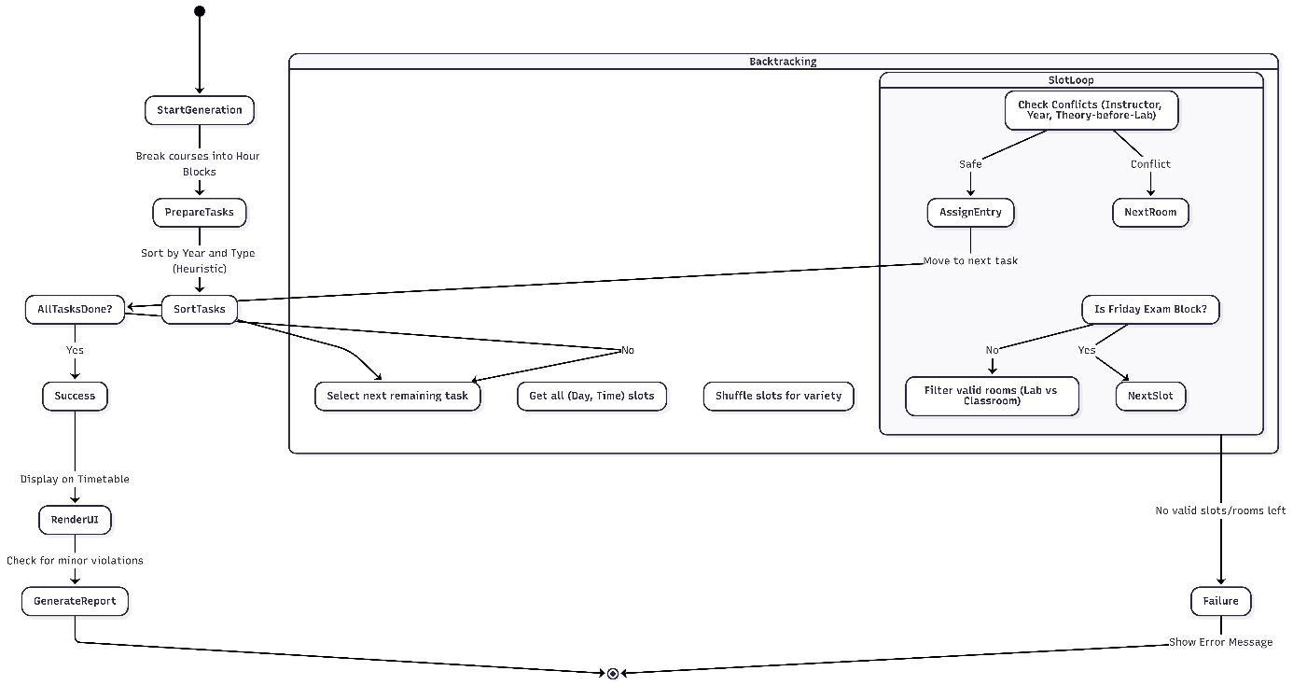

2.3.
GUI Screenshots ¹⁴
- Design Phase: Initial sketches focused on basic input fields and a static grid.
- Final Product: The implemented UI features color-coded course blocks, drag-and-drop support, and real-time conflict warnings.

3. AI Usage & Prompts ¹⁵
Process | Tool Used | Prompt | AI Output Analysis | Human Revision
GUI Design | ChatGPT | "Create a mockup code for a weekly schedule UI using Tkinter." | The code worked but the visual style was outdated. | Integrated the CustomTkinter library for a modern look.
Coding | GitHub Copilot | "Write a 'check_conflict' function that prevents overlapping classes." | The function worked but ignored lunch breaks. | Manually added constraints for lunch hours and weekends.
Reporting | Gemini | "Summarize the technical documentation using academic language." | The output was too long and used irrelevant jargon. | Simplified the language to be more concise and project-specific.

4. V&V Test Reports (Verification & Validation) ¹⁶
4.1.
Test Case Table ¹⁷
- Case 1: Assigning two courses to the same instructor at the same time. Expected: Error Message. Result: Success (System blocked it). ¹⁸
- Case 2: Assigning a Lab course to a standard classroom. Expected: Validation Error. Result: Success (Room type check passed). ¹⁹
4.2.
Bug Fixing with AI Tutor ²⁰
- Bug: RecursionDepthError in the backtracking algorithm during large datasets. ²¹
  - Solution: Used DeepSeek to implement "Pruning" techniques, preventing unnecessary branch exploration. ²²
- Bug: Character encoding issues with Turkish characters in the GUI. ²³
  - Solution: Followed OpenAI’s suggestion to add encoding='utf-8' to all file I/O operations. ²⁴
4.3.
Peer Review Findings ²⁵
- Finding: My partner (Student B) noted that the code was not modular, as all logic was in a single file. ²⁶
- Solution: Refactored the code into logic.py and interface.py to improve readability and maintainability. ²⁷

